MYSQL ASSIGMENT_1
- Create a database named company and a table named employees with the following fields:
- id (INT, Primary Key, Auto Increment)
- name (VARCHAR(100))
- position (VARCHAR(100))
- salary (DECIMAL(10,2))
- date_of_joining (DATE)
Syntax: create database company;
use company;
create table employes (
id INT Primary Key,
name VARCHAR(100),
position VARCHAR(100),
salary DECIMAL(10,2),
date_of_joining DATE
);
Output:-
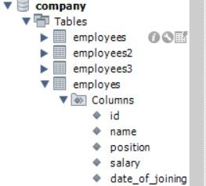
- Insert the following data into the employees table:
- John Doe, Manager, 55000.00, 2020-01-15
- Jane Smith, Developer, 48000.00, 2019-07-10
- Alice Johnson, Designer, 45000.00, 2021-03-22
- Bob Brown, Developer, 50000.00, 2018-11-01
Syntax:- insert into employes values
(1,'John Doe', 'Manager', 55000.00, '2020-01-15'),
(2,'Jane Smith', 'Developer', 48000.00, '2019-07-10'),
(3,'Alice Johnson', 'Designer', 45000.00, '2021-03-22'),
(4,'Bob Brown', 'Developer', 50000.00, '2018-11-01');
OUTPUT:-
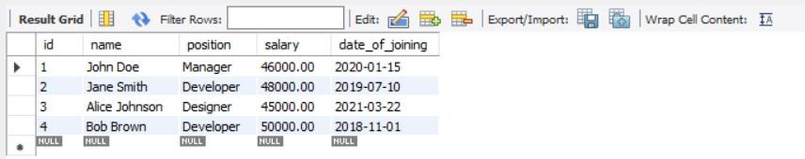
- Write a query to retrieve all employees who are Developers.
Syntax:- select * from employes where position="developer";
Output:- 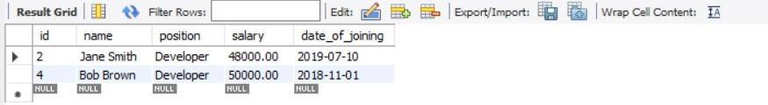
- Write a query to update the salary of Alice Johnson to 46000.00.
Syntax:- update employes set salary = '46000.00' where id= "1";
Output:- 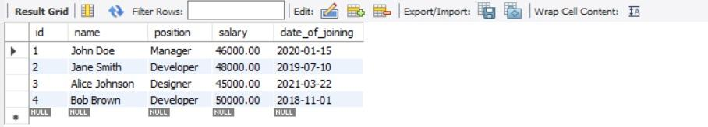
- Write a query to delete the employee record for Bob Brown.
Syntax:- delete from employes where name='Bob Brown';
Output:- 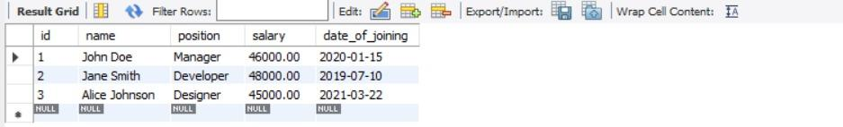
- Write a query to find the employees who have a salary greater than 48000.
Syntax:- select * from employes where salary>48000;
Output:- 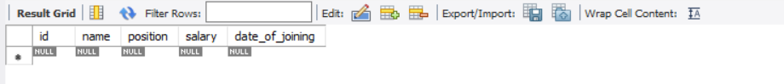
- Write a query to add a new column email to the employees table.
Syntax:- alter table employes add column Email varchar(100);
Output:- 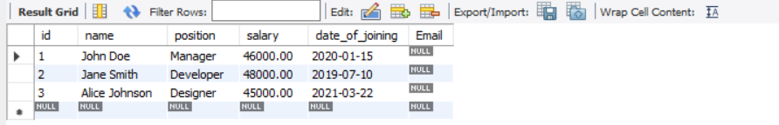
- Write a query to update the email for John Doe to john.doe@company.com.
Syntax:- update employes set email='john.doe@company.com' where name='John Doe';
Output:- 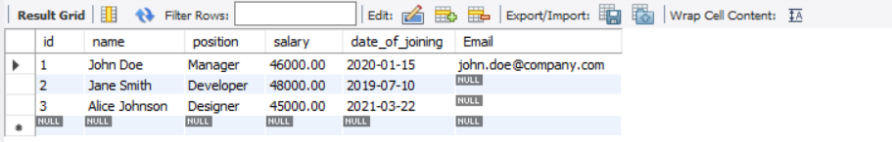
- Write a query to retrieve only the name and salary of all employees.
Syntax:- select name,salary from employes;
Output:- 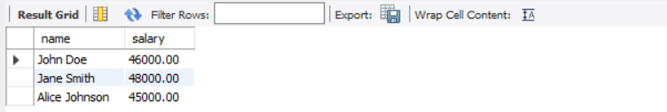
- Write a query to count the number of employees who joined after January 1, 2020.
Syntax:- select count(*) from employes where Date_of_joining= '2020-01-01';
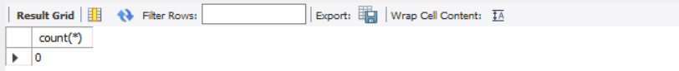
- Write a query to order the employees by salary in descending order.
Syntax:- select * from employes order by salary desc;
Output:- 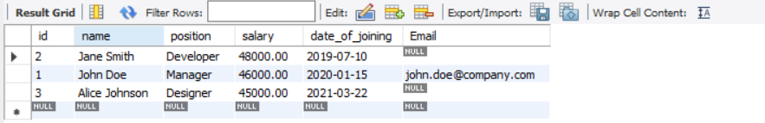
- Write a query to drop the email column from the employees table.
Syntax:- alter table employes drop column Email;
Output:- 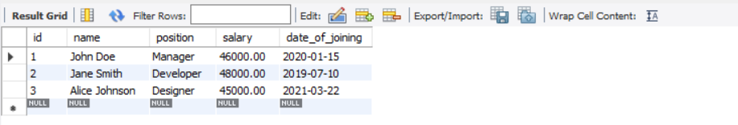
- Write a query to find the employee with the highest salary.
Syntax:- select * from employes where salary=(select max(salary) from employes);
Output:- 